C15.0002 Foundations of Financial Markets
Fall 2010
Sample Midterm Solutions

Multiple choice questions

- A stock has a beta of 1.5 and a volatility (standard deviation) of 50%, and the volatility (standard deviation) of the market portfolio is 20%. What fraction of the stock’s variance is idiosyncratic? (Assume the CAPM holds.)
  - 36%
  - 40%
  - 64%
  - 80%

idiosyncratic var. = total var. – systematic var. = σ² – β² σ_{M}² = 0.5² – 1.5² 0.2² = 0.16
fraction = 0.16/0.5² = 64%

- A stock has a volatility (standard deviation) of 40% and a beta of 1.2, and the volatility (standard deviation) of the market portfolio is 20%. What is the correlation of the stock with the market portfolio?
  - 0.5
  - 0.6
  - 0.4
  - 0.3

β = cov(r,rM)/σ_{M}² = corr(r,rM) σ/σ_{M} → corr(r,rM) = β σ_{M}/σ = 1.2(20%)/40% = 0.6

- If a stock is overpriced relative to its value under the CAPM, where does it plot relative to the Security Market Line (SML)?
  - It lies above the SML.
  - It lies on the SML.
  - It lies below the SML.
  - Can’t tell from the information given.

Overpriced implies a negative alpha, i.e., the future return will be low relative to the prediction from the CAPM (SML).

- You buy a risk-free, 10-year, zero-coupon bond at a given yield. However, after 1 year, the yield on risk-free, 9-year, zero-coupon bonds is now higher than the original yield. The 1-year HPR (holding period return) on the bond is
  - Equal to the original yield.
  - Lower than the original yield.
  - Higher than the original yield.
  - Can’t tell from the information given.

When the yield rises the price is lower that it would have been had the yield stayed constant. A lower sale price implies a lower return.

- If you purchased a stock 6 months ago for $60, just received a dividend of $2/share, and then sold the stock for $64, what is your annualized HPR (holding period return)?
  - 10.0%
  - 21.0%
  - 13.8%
  - 6.7%

HPR = (V_{t}/V₀)^{1/t} – 1 = [(64+2)/60]²-1 = 21%

- The standard deviation of a portfolio of two risky securities will be less than the weighted average of the two component security standard deviations:
  - As long as the correlation of returns is less than 1.
  - Only if the correlation of returns is less than zero.
  - Only if the standard deviations of the two securities is different.
  - None of the above

Only in the absence of any diversification benefit (i.e., perfect correlation) is the portfolio sd equal to the weighted average of the security sd’s.

- Consider the following 3 risky assets:
 | Expected Return | Standard Deviation
A | 10% | 40%
B | 12% | 50%
C | 14% | 60%

The correlations between all the assets are positive, i.e., 0 < ρ_{AB}, ρ_{AC}, ρ_{BC} < 1. What is the correlation between the 2 portfolios that have the following weights in these assets with the residual (if any) invested in the risk-free asset?
 | w_{A} | w_{B} | w_{C}
Portfolio 1 | 50% | 30% | 20%
Portfolio 2 | 20% | 12% | 8%

  - ρ₁₂ = 0
  - 0 < ρ₁₂ < 1
  - ρ₁₂ = 1
  - Can’t tell from the information given.

The relative weights in the risky assets of these 2 portfolios are identical. Therefore, they lie on the same CAL and are perfectly correlated.

- Consider a portfolio that has a short position (i.e., a negative weight) in the market portfolio with the residual invested in the risk-free asset. This portfolio
  - Lies on the CML (Capital Market Line).
  - Is efficient.
  - Is not efficient.
  - Is potentially an optimal portfolio for a mean-variance investor.

This portfolio lies on the investment opportunity set below and to the right of the CML.

- Consider the following 2 risky assets:
 | Expected Return | Standard Deviation
A | 10% | 40%
B | 12% | 50%

What is the expected return on a portfolio with w_{A} = 120% and w_{B} = -20%?
  - 9.4%
  - 10.2%
  - 12.0%
  - 9.6%

E[r]= w_{A} E[r_{A}] + w_{B} E[r_{B}] = 1.2(10%) – 0.2(12%) = 9.6%

- A portfolio consisting of positive amounts invested in two risky securities that have a correlation of zero (ρ = 0) has a global minimum variance portfolio that has a standard deviation equal to:
  - The weighted average of the standard deviations of the two securities.
  - Less than the standard deviation of the less risky security.
  - 0
  - None of the above

For a correlation of 0, the investment opportunity set always bends backwards. (This is not obvious, but it is true.)

- You are considering 3 investments. Investment A pays an annual rate of 5.15% compounded monthly, B pays an annual rate of 5.20% compounded annually, and C pays and annual rate of 5.10% compounded continuously. The ordering from worst to best in terms of effective annual rate (EAR) is
  - A < B < C
  - C < B < A
  - B < A < C
  - B < C < A

EAR = (1+APR/m)^{m} – 1 EAR = e^{APR} – 1
(1+5.15%/12)¹² –1 = 5.27% (1+5.20%/1) – 1 = 5.20% e^{5.10%} – 1 = 5.23%

- You find that the stocks of companies that announce acquisitions exhibit positive abnormal returns (e.g., they go up more than would be predicted by the CAPM) prior to these public announcements. This is evidence:
  - Against the weak form or market efficiency.
  - Against the semi-strong form of market efficiency.
  - That the CAPM doesn’t hold.
  - None of the above

Because the abnormal return is prior to the announcement it is not “predictable”; therefore, it is not inconsistent with any of these theories.

- Security A has higher price volatility and higher volume of trading than security B. All else equal, the equilibrium bid-ask spread of A should be
  - Greater than B.
  - Less than B.
  - Equal to B.
  - Can’t tell from the information given.

Ignore this question for the purposes of the midterm (although it is covered in the BKM reading).

- The expected return on the market portfolio is 10%, the standard deviation of the market return is 20%, and the risk-free rate is 4%. Assuming the CAPM holds, what is the expected return on a portfolio with a beta of 0.8 and a standard deviation of 22%?
  - 4.8%
  - 11.0%
  - 8.8%
  - 12.0%

E[r] = r_{f} + β (E[r_{M}] – r_{f}) = 4% + 0.8(10% – 4%) = 8.8%

- The expected return on the market portfolio is 10%, the standard deviation of the market return is 20%, and the risk-free rate is 4%. Assuming the CAPM holds, what is the standard deviation of an efficient portfolio with a beta of 0.6?
  - 12.0%
  - 7.6%
  - 6.0%
  - 8.6%

σ = β σ_{M} = 0.6(20%) = 12%

- If you buy a 20-year, $1,000 face amount, zero coupon bond with a yield of 4% and sell it 19 years later at a price of $960, the annualized HPR (holding period return) over these 19 years is
  - 4.00%
  - 3.99%
  - 4.17%
  - 4.01%

purchase P = 1000/(1+4%)²⁰ = 456.39 HPR = (960/456.39)^{1/19} – 1 = 3.99%

Numerical problems

- You plan on taking a cruise every 2 years, starting a year from now and ending in 41 years (i.e., cruises at t = 1, 3, 5, …, 41). You expect each cruise to cost $3,000. How much do you need to deposit today, in an account that pays 10%, annual compounding, to fund these vacation plans?

The length of a period is 2 years, so r = (1+10%)² – 1 = 21%.
There are 21 cash flows in the annuity.
The annuity valuation formula gives the value 1 period (2 years) before the first cash flow, i.e., at year -1. Therefore the annuity value needs to be brought forward 1 year at 10%.

- Consider the following 2 risky assets:
 | Expected Return | Standard Deviation
A | 10% | 40%
B | 12% | 60%

If the assets are perfectly negatively correlated (ρ = -1), what is the expected return on the portfolio of these assets that is risk-free?

For perfect negative correlation
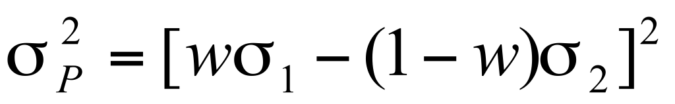
Setting this equal to zero and solving for the portfolio weight
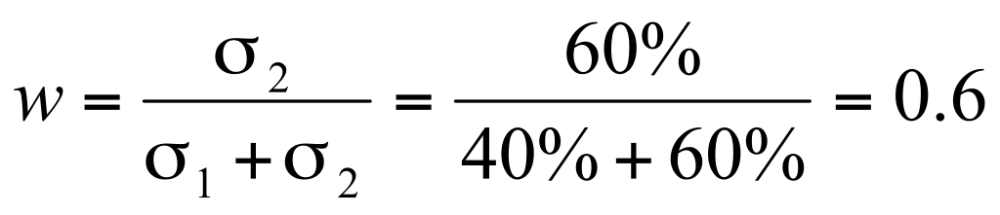
Therefore, the expected return is

- Consider the following stock price and dividend history over the past 2 years:
 | -2 | -1 | 0
Price | 100 | 100 | 102
Dividend |  | 5 | 3

Note that the price given at each point is the price after the payment of the dividend. Assuming that you could reinvest the dividend payments in the stock, what is the annualized HPR (holding period return) on the stock over this period?

There are 3 approaches that give an identical answer:

- Reinvesting the $5 dividend at time -1 in the stock over the last year generates
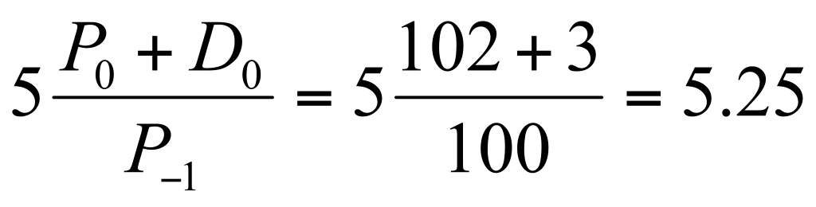
Thus the final value, including reinvestment, is
and the annualized HPR is
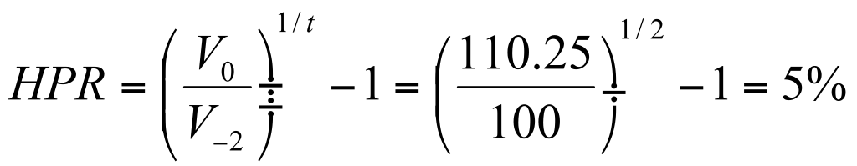

- The returns in the 2 years are
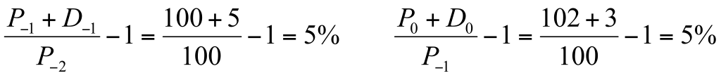
Since the returns in the 2 years are identical, the time-weighted return (geometric average), the dollar-weighted return (IRR), and the annualized HPR are identical: HPR = 5%

- Calculate the IRR
Reinvesting at the IRR is equivalent to reinvesting in the stock. Thus the HPR is the IRR.

- Assume the CAPM holds. You are given the following information about 2 stocks:
 | Expected Return | Standard Deviation | Beta
A | 10% | 40% | 1.0
B | 14% | 50% | 1.5

The correlation between the returns on the stocks is 0.3 (ρ = 0.3). What is the expected return on an asset with a beta of 0.6?

The slope of the SML is the market risk premium
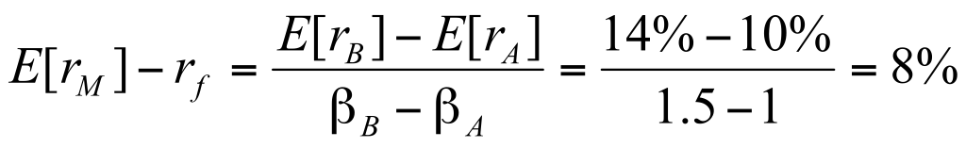
There are now 2 approaches:

- The unknown asset is also on the SML, thus
or equivalently using asset B.

(ii) Find the risk-free rate using the SML
or equivalently using asset B. Plug back into the SML for the unknown asset

